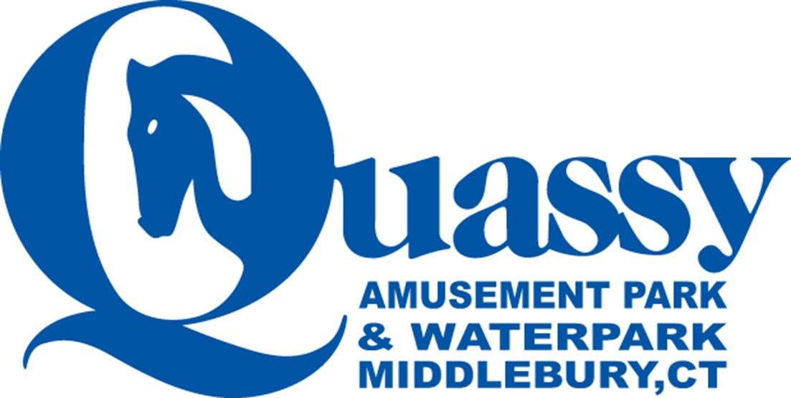

CT SWIMMING DAY AT QUASSY AMUSEMENT
Saturday June 29, 2024 11a – 5p
Food Served from 12:30p – 3:30p

All participants will receive a wrist band that will allow them unlimited access to all amusement park rides and the water park area and Free Parking!!!

Food Menu includes unlimited:
burgers, hot dogs, chicken nuggets, French fries, chicken wings, barbeque ribs, corn on the cob, ziti, corn on the cob, veggie burgers and salads.

Rates for CT Swimming Registered Members
12 and under members $20.00
13 and over members $25.00
Rates for Non- CT Swimming Registered Attendees
12 and under $ 42.00
13 and over $52.00

All children two and under are free
ALL MUST SIGN-UP IN ADVANCE. DEADLINE IS 6/24 at 3:00p. NO WALK-UPS.

Only registered and paid participants will be allowed entrance to the pavilion area where the food is being served.
